WORKFLOW & SECURITY DOCUMENT

## 1.Database design

### 1.1Employee list

|  |  |  |  |  |
| --- | --- | --- | --- | --- |
| ID | Name | DOB | Public key | Role |

* ID: each hospital’s employee has a unique number.
* Public key: unique public key of every employee.
* Role: there are 2 roles which are trainee and supervisor.

### 1.2Trainee records

|  |  |  |  |  |  |  |  |  |  |
| --- | --- | --- | --- | --- | --- | --- | --- | --- | --- |
| QR record | Trainee ID (encrypted) | Finished Tasks(encrypted) | Self-rating(encrypted) | Date(encrypted) | Supervisor ID | Sign status(encrypted) | Supervisor’s rating(encrypted) | Feedback(encrypted) | Hash |

* QR record: Each record has a unique QR code to identify the record.
* Trainee ID: has a reference to employee list’s ID.
* Finished tasks: contains all the tasks have been finished in the record.
* Self-rating: the level that the trainee rate by oneself.
* Supervisor ID: has a reference to employee list’s ID.
* Date: the date when the tasks finished.
* Sign status: shows if the record has been signed or not.
* Supervisor’s rating: the level that the supervisor rates the trainee.
* Feedback: optional opinions of the supervisor for the trainee.
* Hash: hashed Finished tasks, Self-rating, Supervisor’s rating, Feedback

## 2.Security workflow

### 2.1 Make Record

**Security Modules need to be used:**

* Encryption Module (encrypt the record for trainee)

When create a new record, train will fill in the Finished Tasks, Self-rating, Date and supervisor ID and this information will be encrypted by the supervisor public key. QR record will be generated by application automatically. Sign status will be “Unsigned” until the supervisor rates the record by fill in the Supervisor’s rating and Feedback.

### 2.2 Make assessment

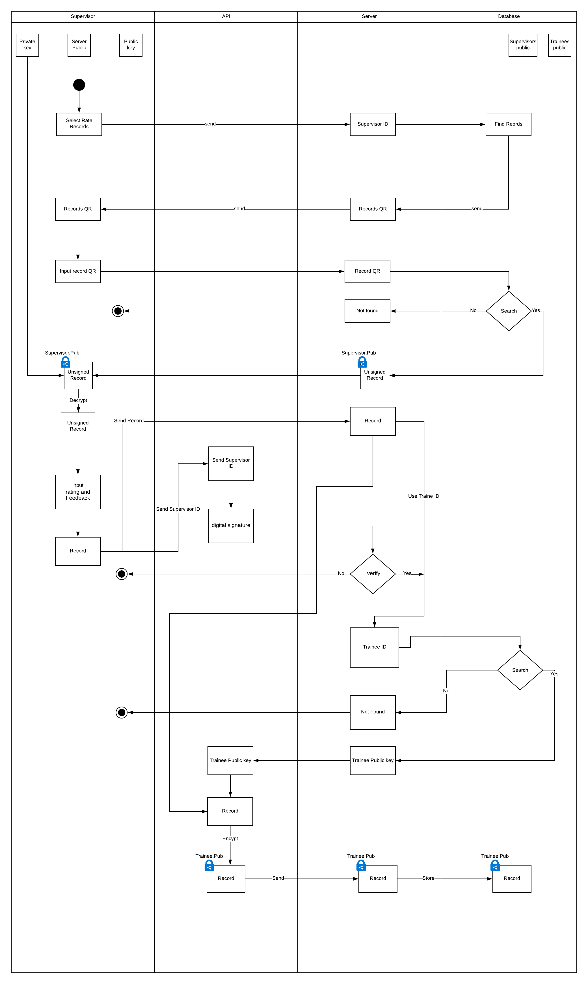

**Security Modules need to be used:**

* + Decryption Module (decrypt the record)
  + Encryption Module (encrypt the record for supervisor, trainee)
  + Digital signature Module
  + Hash Module

When supervisor want to rate records, application will use supervisor’s ID to find all the records need to be rated by the supervisor. Then supervisor will input the QR of the record. The application will load the record and supervisor will fill in the Supervisor’s rating and Feedback. After that supervisor select submit and the system will use supervisor’s ID to make digital signature for the server to verify if it is approved, the server will update the record and encrypt it by trainee public key.

### 2.3 Trainee see Profile:

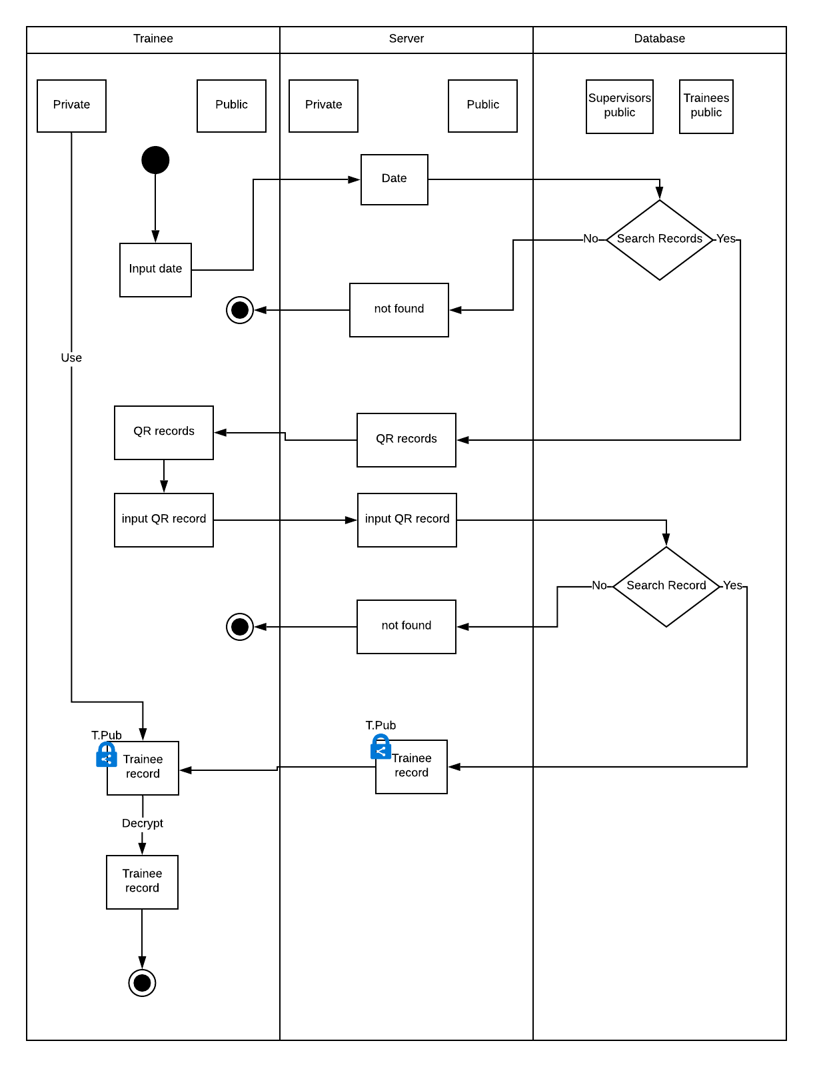

**Security Modules need to be used:**

* Decryption module (decrypt the game record).

To see the profile trainee will input the date of a record then application will return all the QR records of the date, so trainee can select one of those QR code to see the profile. After that the record will be decrypted on the trainee side.

### 2.4 Trainee shares profile to supervisor

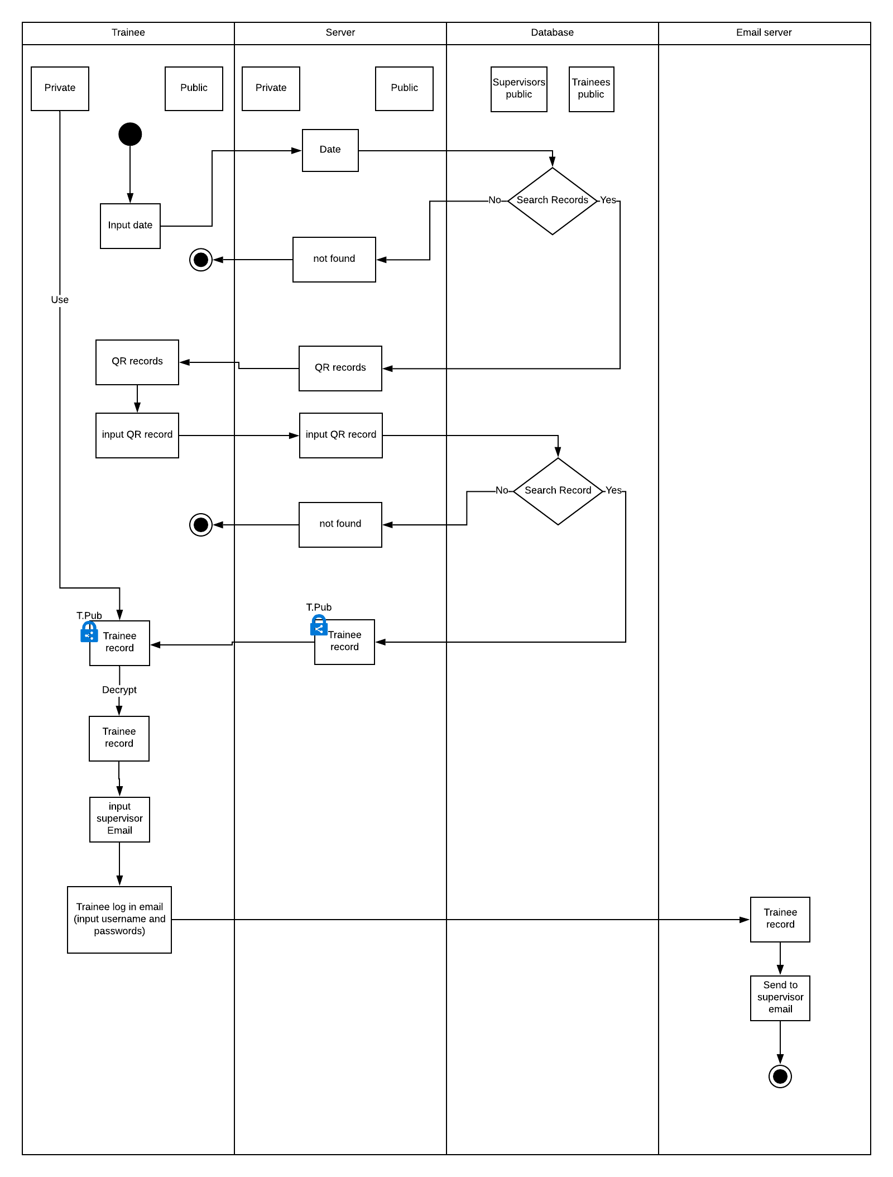

When trainee want to share profile to a supervisor. The trainee will select share profile and then input the supervisors’ email then the record will be sent to the supervisor. The process of select a profile to share is like the See Profile Process.